Try starting your family tree: Family Tree for _ _ _ _ _ _ _ _ _ _ _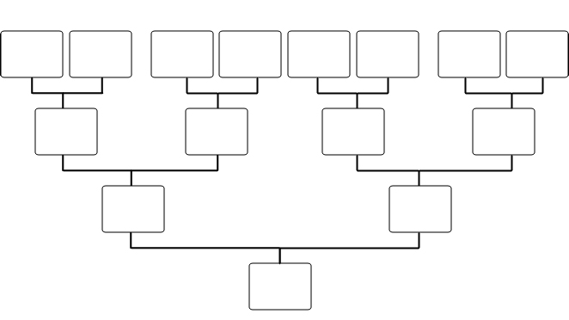
Your Name
Father
Mother
Grandparents
Great Grandparents

